

**NOISE POLLUTION MONITORING SYSTEM**

**DEPARTMENT OF BIO MEDICAL ENGINEERING**

**PROJECT SUBMISSION PHASE-5**

**Team members;**

**ARULMURUGAN R**

**AROKKIYADASS J**

**DINESHPRABU M**

**GIRINATH S**

**CHANDRU S**

**Presented by;**

**AROKKIYADASS J**

**Abstract;** Presently, noise pollution has become a very big issue around the world. The adverse effects of this pollution include hearing impairment, negative social behavior, annoyance, sleep disturbance and intelligibility to understand people’s speech. In learning context, noise can affect understanding and behavior of people and places with high noise level are not suitable for learning and teaching process. Internet of Things (IoT) technology is one of the best choices to monitor the noise or sound intensity in the environment for the safety of human being. The aim of this paper is to deliver a development of an IoT based noise monitoring system comprises of a sound sensor, an IoT platform called NodeMCU, LCD and LEDs. The system will provide a real-time alert if the noise exceeds the threshold noise limit set by Environmental Department of Health standard. Equipped with an Android application, the data from the sound sensor will be transferred into the cloud server and subsequently transferred into the app for display and to enable remote monitoring. A case study is carried out using the developed prototype to ascertain the noise comfort for Universiti Teknologi Malaysia (UTM) students for studying or learning purpose. The sound level is measured for two different days during weekend and weekday. Based on Charted Institution of Building Service Engineers (CIBSE), 60dBA is the permissible ambient level and any readings that above 60dBA can interrupt speech intelligibility. From the research, the suitable time for students to study for weekend is all day starting from morning until midnight. As for weekday, the most suitable time to study is during midnight. These justifications are made based on the readings

**INTRODUCTION** ; Internet of things or commonly called IoT refers to the network of physical devices, vehicles, electronic appliances and other items embedded with sensors, software and connectivity which enables these things to connect, collect and exchange data without requiring human-to-human or human-to-computer interaction . IoT is currently growing due to some factors such as convergence of multiple technologies, real time analytics, machine learning, commodity sensor and embedded systems . The IoT was firstly coined by Kavin Ashton of Procter and termGamble and later by MITs Auto-ID centre (1999) Cisco System estimated that IoT was developed between 2008 and 2009 . It is widely used in today’s applications such as consumer, commercial, industrial and infrastructure spaces. There is a lot of thing that can be implemented for the consumers’ daily uses. Take a smart home for instance, IoT is used in this invention to control lighting, heating, air-conditioning, media and security systems. This means it can save energy as it can automatically ensure lights and other electronicscomponents are turned off if there is no people in the house . There are several inventions that are based on this smart home concept like Apple’s home kit, Amazon Echo, Apple’s home pod and Samsung Smart things’ hub. Smart home also is used for elder care to assistance for disabilities and elder people . It uses voice control system to assist the users with sight and mobility limitations and sensors to monitor for medical emergencies such as falls seizures .

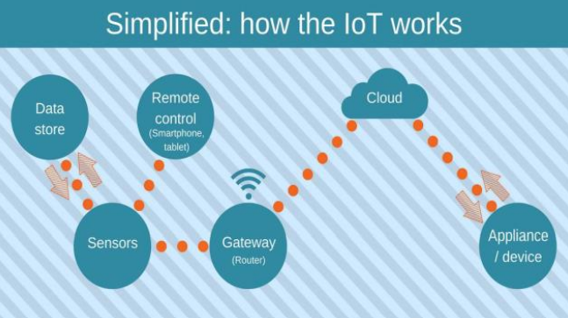

**PROBLEM STATEMENT;** Noise monitoring is very crucial since 20% of the European Union (EU) population or close to 80 million people suffer from noise level that experts consider to be unacceptable [9]. IoT allows an exchange of information to and from a device or thing and due to its flexibility and low cost, IoT is getting popular day by day [10]. Thus, IoT is very suitable to be implemented in monitoring the noise level in some areas to deal with the problem. The demands of modern society lead to the creation of noise sources such as industrial sources, transport vehicles, defence equipment and construction. The most significant example is inside UTM. Noise coming from vehicles and construction sites have significantly distract the focus and the intellectual development of the students. This issue results in the needs of a system that will monitor the noise level at that specified areas. It is also an alternative for students to know the suitability to study via app .

**Methodology;Hardware Development;** For the hardware parts, LM 393 sound sensor is used to read the readings of the sound level from the environment. The reading of sound sensor is calibrated using the real sound level meter to get the accurate readings of the sound level. The 16x2 LCD will show the values of sound level at that researched area and give the warning that says the level of sound is high when the measurement exceeds the set value. If the users could not read the readings due to poor eyesight, they can know the level of sound by using the light emitting diodes (LED) which in red, blue and green colour placed below the LCD. LED acts as an indicator to indicate when the noise is very high. It will turn to red, blue for low noise while green for intermediate level. All these components such as sound sensor, LCD, and LEDs will be connected to the ESP8266 NodeMCU.

**App Development;** As the app was created by using Android Studio, the app will display the data taken from the sound sensor. Android Studio is a software to create app use JAVA language to design an Android development. The app has four features which are the reading of sound level in dBA, the level of warning based on the reading of sound intensity, the possible sound that contributes to the sound level and the suitability for students to study. The app gives different level of warning such as “low”, “normal”, “high” and “very high”.

**Working Principle of the Prototype;** The sound sensor will record the readings of sound level at the researched area. Then, the data is sent over to the cloud server called Firebase. Firebase is a development platform that is specialized for web application and mobile developed by Firebase Incorporation . Firebase is chosen as the cloud server for this system because it can easily be connected to Android Studio. The data is stored in Firebase real-time database which the user can also access via web browser. Then, data from Firebase is transferred to the app. The users can use the app to know the reading of sound level and they also can know which time is suitable to study and what factors contribute to the high noise based on the value of the sound level.

**PYTHON PROGRAM:**

import time

from noise_sensor_library import NoiseSensor # Replace with actual library

def monitor_noise():

# Initialize the noise sensor

sensor = NoiseSensor()

while True:

# Read noise level from the sensor

noise_level = sensor.read_noise_level()

# Send noise level data to the IoT platform (replace with actual implementation)

send_to_iot_platform(noise_level)

# Log the data or take further actions as needed

# Wait for a specific interval (e.g., 1 minute)

time.sleep(60)

def send_to_iot_platform(noise_level):

# Replace the following line with code to send data to your IoT platform

print(f"Sending noise level data to IoT platform: {noise_level}")

if __name__ == "__main__":

monitor_noise().

**Results and Observations;** The prototype is calibrated using actual sound level meter to get the accurate measurement of sound level or sound intensity. The prototype is used to measure the sound level at five different times which are during morning, afternoon, evening, night and midnight at a place where UTM students are staying. The reading is taken 30 minutes per range of time. Within that time, the lowest and highest sound intensity were recorded and from the readings, the range of sound level was determined during that specific range of time.The allowable noise level that is suggested for researched area is below 55dBA for daytime and 45dBA for night. This justification is based on the researched area which is categorized as medium density residential area. Based on CIBSE, 60dBA is the maximum allowable sound level to achieve comfort in a building. Any sound that exceeds 60dBA will interrupt the speech intelligibility and the

learning process. Based on Table 1, during weekend, the sound level in the morning and night are in between 47dBA to 60dBA and 42dBA to 59dBA. It shows that noise problem does occur during that time because the value of 55dBA is included in the range. As for afternoon, evening and midnight, all readings of sound level are below the allowable noise level standard which are during afternoon (43dBA – 49dBA), evening (43dBA – 49dBA) and midnight (34dBA -35dBA). Thus, during these times, noise problem does not occur. As for weekend, the suitable time for students to study is the whole day starting from morning until midnight because all readings are showing that they are within permissible level of comfort which is 60dBA.. As for weekday, the sound level during morning until night are all above the allowable noise level standard which are; morning (57dBA – 71dBA), afternoon (54dBA – 69dBA), evening (62dBA –69dBA) and night (48dBA – 63dBA). It can be concluded that during that specific time, the noise problem does occur. As for midnight, the sound level recorded is 34dBA to 35dBA which indicates no noise problem. The reading at midnight also shows that it is less than 60dBA which makes it a comfortable study time for students.

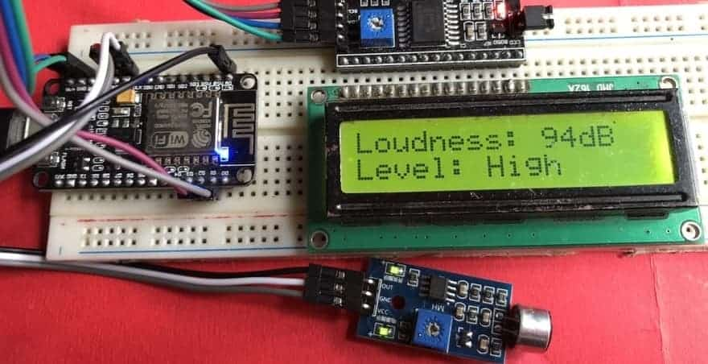

**Conclusion;** People thought that noise pollution is merely an annoyance but it is actually very important to monitor noise level because according to research, people who are exposed to noise for a long duration of time can have hearing loss, sleep disturbance, high blood pressure and injuries [16].Besides, it can affect the learning process of people in terms of understanding and behaviour. Thus, this research investigates and subsequently proposes the suitable time for students to study by utilising the cloud server and android application to realize an IoT based noise monitoring system. From the prototype, it also can be determined the dominant sound that increases the noise level in the researched area. The app can display the reading from the prototype successfully. Based on the results, it can be concluded that the students can study throughout the day starting from morning until midnight during weekends because the noise level is still under the allowable standard which is 60dBA according to CIBSE. As for weekdays, the suitable time to study is found out to be at midnight because the readings are below 60dBA for that time. The limitation of this study is that it is conducted within UTM campus only. In addition, the app can only show the reading from only a single prototype as well as the prototype and app can only operate when there is an internet connection. This system can be improvised in future to include measurements outside UTM such as at schools and airports.